MINISTRY OF SCIENCE AND EDUCATION NATIONAL TECHNICAL UNIVERSITY “KHARKIV POLYTECHNIC INSTITUTE”

DEPARTMENT OF SOFTWARE ENGINEERING AND MANAGEMENT INFORMATION TECHNOLOGIES

Report from lab#2

Discipline “Fundamentals of Software Engineering”

Executed by: Student of group 1.КН.201.8г

CHUKWU IRELE AMORIN

Checked by: Senior lecturer

K.V. Melnik

Kharkiv

2018

Goal: Learn basics C++ Task:

1. Develop the code for the task from previous lab
2. 2- Prepare the report of the work

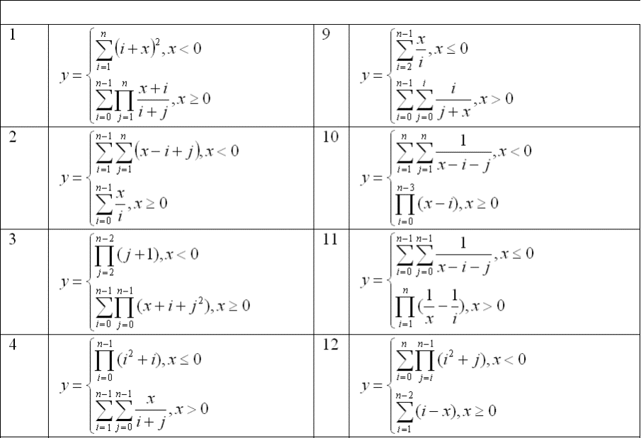

#include "pch.h"

#include <iostream>

#include <math.h>

using namespace std;

void checkinput(int n)

{

if (n <= 0)

{

throw " incorrect data";

}

}

int getX()

{

int x;

cout << "input x : ";

cin >> x;

return x;

}

int getN()

{

int n;

cout << " \n input n ,n should be greater than 0 'zero': ";

cin >> n;

checkinput(n);

return n;

}

double functionY(int x, int n)

{

double i, j;

double y = 0, z;

if (x < 0)

{

for (i = 1; i < n + 1; i++)

{

y = y + (i + x) * (i + x);

}

return y;

}

else

{

for (i=0; i < n- 1; i++)

{

z = 1;

for (j = 1; j <= n; j++)

{

double k = (x + i) / (i + j);

z = (z * k);

}

y = (y + z);

}

return y;

}

}

int main()

{

try {

cout << "the result of the function of x is : " << functionY(getX(), getN()) << endl; ;

}

catch (const char* ex)

{

cout << ex << endl;

return -1;

}

catch (...)

{

cout << "the program has an error " << endl;

}

}

Task 2: calculating with a range

#include "pch.h"

#include <iostream>

#include <math.h>

using namespace std;

double x;

int range_a, range_b;

int n;

int step;

int main()

{

do

{

cout << "input n, n must be greater than 0 : ";

cin >> n;

} while (n <= 0);

do

{

cout << "input step, step must be greater than 0 : ";

cin >> step;

} while (step <= 0);

cout << "\n input lower range : ";

cin >> range_a ;

do

{

cout << "\n input higher range ,higher range should be greater than lower range: ";

cin >> range_b;

} while (range_a >= range_b);

for (range_a; range_a <= range_b; range_a += step)

{

int i, j;

double y = 0, z;

x = range_a;

if (x < 0)

{

for (i = 1; i < n + 1; i++)

{

y = y + (i + x) * (i + x);

}

cout << " \n the result of the function of step x = "<< x << " is : " << y << "\n";

}

else

{

for (i = 0; i < n - 1; i++)

{

z = 1;

for (j = 1; j <= n; j++)

{

double k = (x + i) / (i + j);

z = (z * k);

}

y = (y + z);

}

cout << " \n the result of the function of step x = " << x << " is : " << y << "\n";

}

}

}

**Conclusion**: During the process of performing the lab I have learned basic principles of C++